COMMUNITY PROFILE: THNEEDVILLE
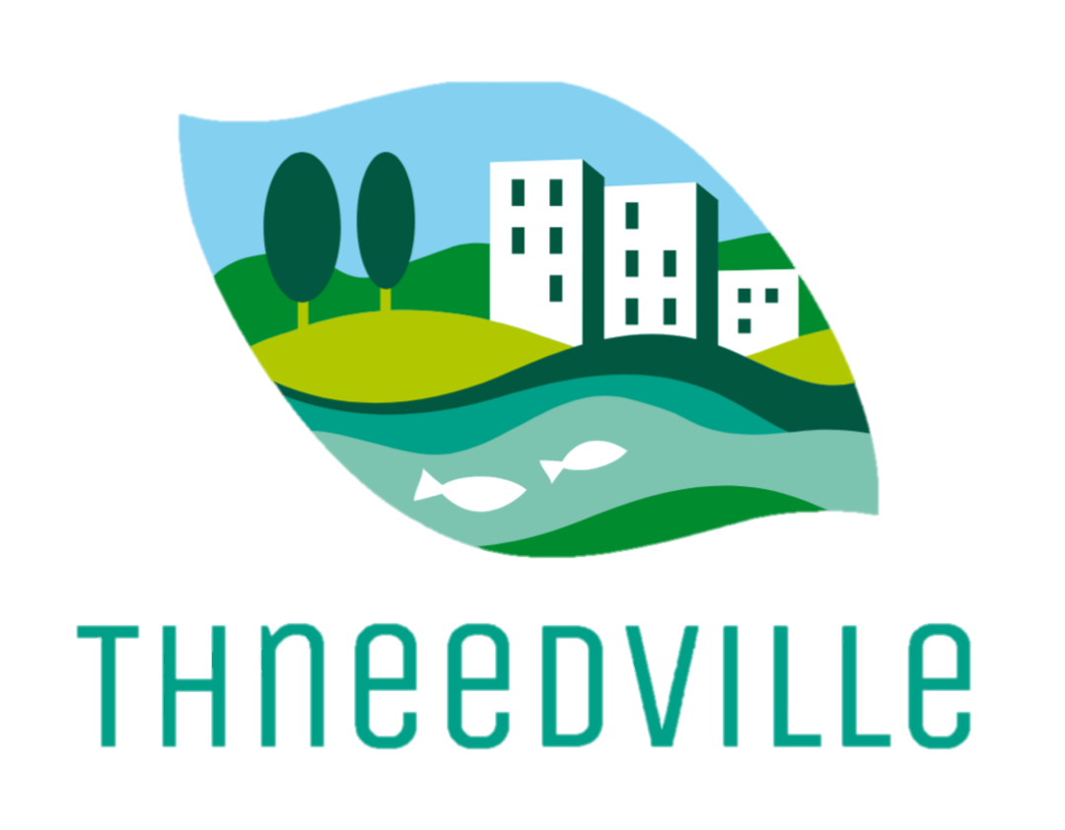

Location: Thneedville is a town situated on Thneed Island.

Population: Thneedville has a moderate population size, with approximately 5,000 residents. The community is diverse and multicultural, reflecting a mix of Australian and international backgrounds.

Population Makeup: The population makeup of Thneedville is a blend of various ethnicities, including Australian, Chinese, Korean, Pakistani, and more. This multicultural composition enriches the town's cultural fabric and fosters an atmosphere of inclusivity.

Employment by Industry: The primary industries in Thneedville include agriculture, tourism, fishing, and services. Agriculture, particularly dairy farming and cheese production, holds a significant place in the local economy. Tourism is also a key sector, with visitors attracted to Thneedville's scenic beauty and unique offerings.

Age Profile: Thneedville has a balanced age profile, with a mix of different age groups. The population includes young families, working professionals, and retirees who contribute to the diverse dynamics of the community.

Income: The income levels in Thneedville vary, but the town generally has a middle-income focus. Some residents are employed in lucrative positions within the dairy industry, while others work in supporting roles or tourism-related services.

Dominant Industries: The dominant industries in Thneedville are agriculture and tourism. The island's fertile lands and favorable climate support a thriving agricultural sector, particularly in dairy farming and cheese production. The town's natural beauty, pristine beaches, and outdoor recreational activities attract tourists throughout the year, driving the growth of the tourism industry.

Economic Development: Thneedville places an emphasis on sustainable economic development. Efforts are made to strike a balance between preserving the island's natural resources and fostering economic growth. The town encourages entrepreneurship and innovation, particularly in sustainable agriculture, eco-tourism, and niche industries that complement the island's unique environment.

Social Issues: Like any community, Thneedville faces social challenges that require attention and support. Affordable housing, access to quality healthcare services, and educational opportunities for all residents are some of the key social issues that the town addresses. Thneedville strives to create an inclusive and supportive environment for its residents, ensuring their well-being and fostering community cohesion.

